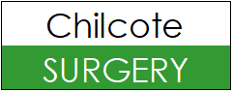

What did we do?
1st Oct 2025 – 31st Dec 2025
Patient list size: 15,854
1,041 ‘Did Not Attend’ appointments (DNAs)
= 85 hours
1,213 referrals completed
28,554 telephone appointments conducted
14,183 Online Triage forms received
4,182 Patients’ lab results processed
12,566 face-to-face appointments conducted
7,712 prescriptions issued
7,853 documents processed
608 home visits conducted
21,308 calls answered

